**LOW LEVEL DOCUMENTATION**

**INVESTMENT ANALYSIS**

**Revision Number - 1.1**

**Last Date of Revision - 24/09/2022**

**Arzoo Meshram**

**Document Control**

| **Date** | **Version** | **Description** | **Owner** |
| --- | --- | --- | --- |
| 28th August 2022 | 1.0 | Introduction, Problem Statement | Arzoo Meshram |
| 18th Sept 2022 | 1.1 | Dataset Information, Architecture Description | Arzoo Meshram |
| 24th Sept 2022 | 1.2 | Final Revision | Arzoo Meshram |

**1) LOW LEVEL DESIGN DOCUMENTATION :**

The purpose of this document is to present a detailed description of the Investment Analytics prediction analysis technique. It will explain the necessary steps which have to be followed before any analysis can begin. LLD describes the class diagrams with the methods and relations between classes and programs specs. It describes the modules so that the programmer can directly code the program from the document. This document is intended for both the stakeholders and the developers of the system and will be proposed to the higher management for its approval.

The LLD will be focusing on the below objectives:

* Understanding the Problem.
* Data Acquisition.
* Data Preprocessing
* Development of models
* Auditing accuracy
* Model Finalizing
* Represent it in Report (PowerBi)

**2) SCOPE :**

The LLD documentation presents the detailed structure of the Investment analytics for each of its individual components. The goal of LLD is to give the internal logical design of the actual program code. Low-level design is created based on the high-level design. The LLD documentation contains the complete description of the model used along with the comparisons of the proposed model/library compared with a baseline(existing) model against a set of metrics.

**3) PROJECT INTRODUCTION:**

The practice of evaluating an investment for profitability and risk is known as Investment Analysis. Its ultimate goal is to determine whether a certain investment is a good fit for a portfolio. It can also range from a single bond in a personal portfolio to a fledgling business investment and even large-scale corporate ventures.

Investment is a game of understanding historic data of investment objects under different events but it is still a game of chances to minimize the risk we apply analytics to find the equilibrium investment.

The given dataset contains Sector and Financial year-wise data of Foreign Direct Investment (FDI) in India.

**4) CONSTRAINTS:**

Our analysis is done based on a limited dataset provided for different 63 sectors and 17 years investment. The analysis is done sector and year wise.

**5) RISKS:**

Document specific risks that have been identified or that should be considered.

**6) OUT OF SCOPE:**

Delineate specific activities, capabilities, and items that are out of scope for the project.

**TECHNICAL IMPLEMENTATION:**

1. **PROBLEM STATEMENT -**

Investment is a game of understanding historic data of investment objects under different events but it is still a game of chances to minimize the risk we apply analytics to find the equilibrium investment.

To understand the Foreign direct investment in India for the last 17 years from 2000-01 to 2016-17. This dataset contains sector and financial year-wise data of FDI in India

Sector-wise investment analysis

Year-wise investment analysis

Find key metrics and factors and show the meaningful relationships between attributes.

Do your own research and come up with your findings

1. **DATASET**

Following Dataset is provided by iNeuron Database -

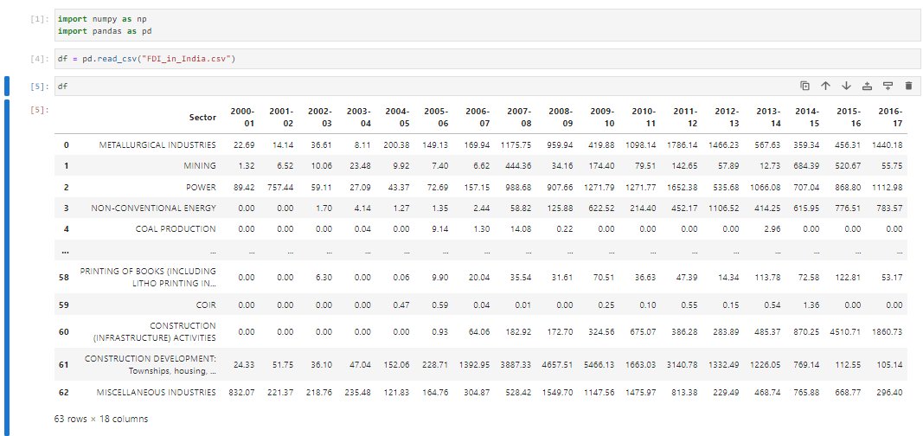

It contains information about Sector wise and Year wise data.

It has 63 unique sectors and 17 columns from 2000-01 to 2016-17 historic data.

1. **ARCHITECTURE:**



**3.1 ArchitectureDescription**

* + 1. **Raw Data Collection-**

The Dataset was taken fromiNeuron provided Project DescriptionDocument.

https://drive.google.com/drive/folders/1M5z7z1NmWar7y1eFs67orfjqHL0iSViL?usp=sha ring

### **Data Pre-Processing-**

Before building any model, it is crucial to perform data pre-processing to feed the correct data to the model to learn and predict. Model performance depends on the quality of data to the model.

This Process includes-

* + - 1. Handling Null/MissingValues

### **DataCleaning -**

Data cleaning is the process of fixing or removing incorrect, corrupted, incorrectly formatted, duplicate, or incomplete data within a dataset.

* + - 1. Remove duplicate or irrelevant observations
      2. Filter unwanted outliers
      3. Renaming required attributes

### **Exploratory Data Analysis (EDA) -**

Exploratory Data Analysis refers to the critical process of performing initial investigations on data to discover patterns, spot anomalies, test hypothesis and to check assumptions with the help of summary statistics and graphical representations.

### **Reporting -**

Reporting is a most important and underrated skill of a data analytics field. Because being a Data Analyst you should be good at report building because your model will be used by many stakeholders who are not from technical background.

* + - 1. High Level Design Document(HLD)
      2. Low Level Design Document(LLD)
      3. Architecture
      4. Wireframe
      5. Detailed Project Report
      6. PowerPoint Presentation

### **Modeling -**

Data Modeling is the process of analyzing the data objects and their relationship to the other objects. It is used to analyze the data requirements that are required for the business processes. The data models are created for the data to be stored in a database. The Data Model's main focus is on what data is needed and how we have to organize data rather than what operations we have to perform.

### **Deployment -**

I have created Two pages in the PowerBi dashboard, One for sector and second for year wise.

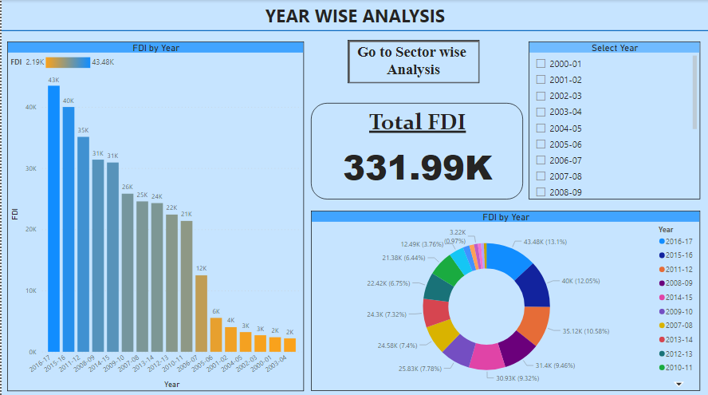

Below are the visualizations used in this project -

BAR GRAPH

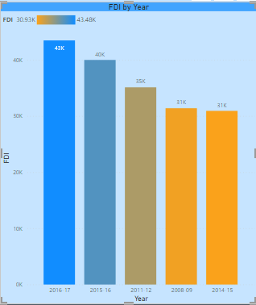

SLICER

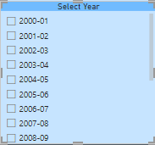

DONUT CHART

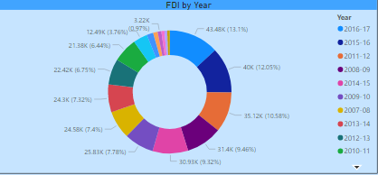

CARD

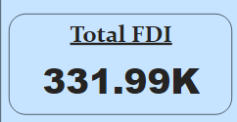

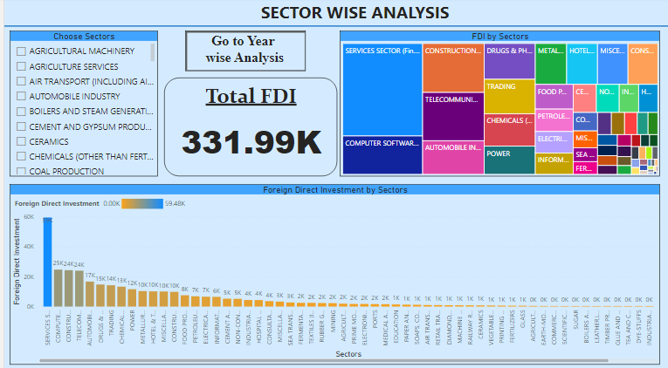

TREE MAP

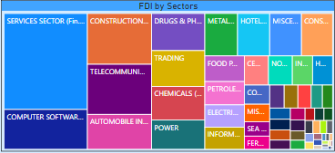

BAR GRAPH

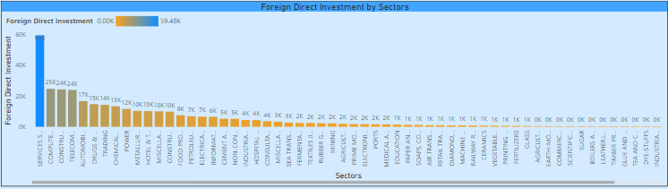

SLICER

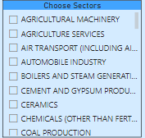

CARD

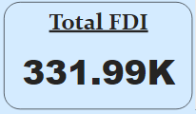

BUTTON

